**QUE-35.3.1-Explain and perform Importing table contents from Mysql to Hive using Sqoop.**

**ANS-35.3.1-**

**INPUT-**

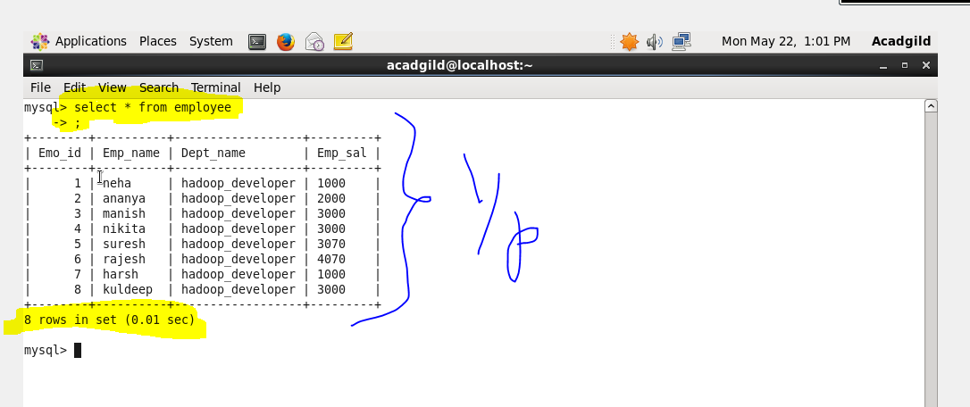

**SQOOP COMMAND TO DO IMPORT AND ITS EXPLANATION-**

**Sqoop import-import is used when we are importing data from rdbms to Hadoop ecosystem**

**--connect -> It is used to give the JDBC Url of database**

**--Username🡪user name of database**

**--P🡪password of database**

**--table 🡪 give the table you want to copy from MySql**

**--target-dir🡪 temporary target directory used by Sqoop for transferring which will be deleted after the import is finished**

**--hive-import🡪Indicating a hive import**

**--hive-table🡪table which will be created and on which data will be written(in our case employee-mysql)**

**-m1🡪number of mappers that should run**

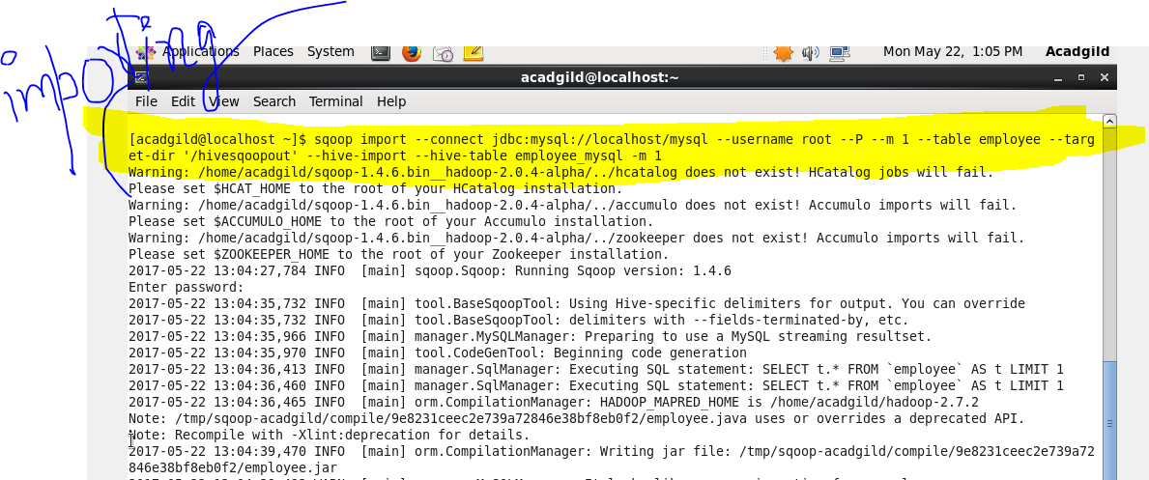

**From the below picture the table is successfully imported to HIive-**

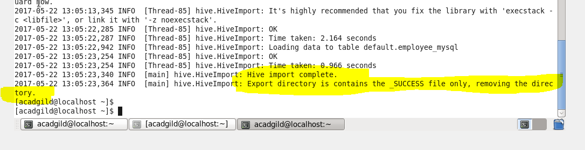

**OUTPUT-**

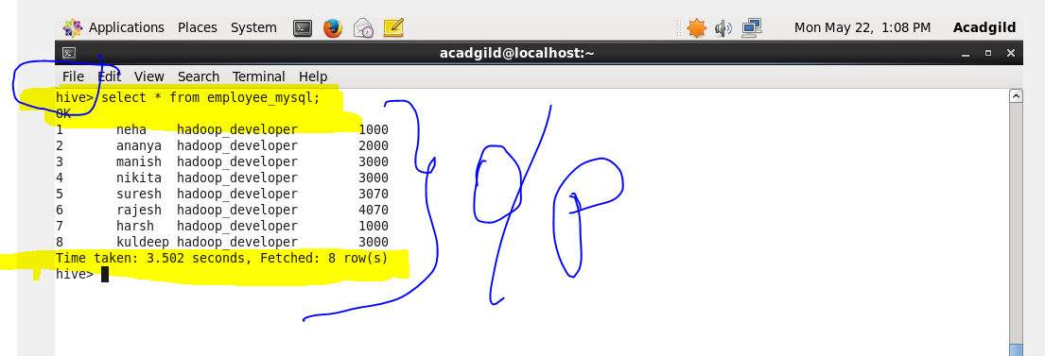

**QUE-35.3.2-Explain and perform Importing table contents from Mysql to HBase using Sqoop.**

**ANS-35.3.2-**

**INPUT-**

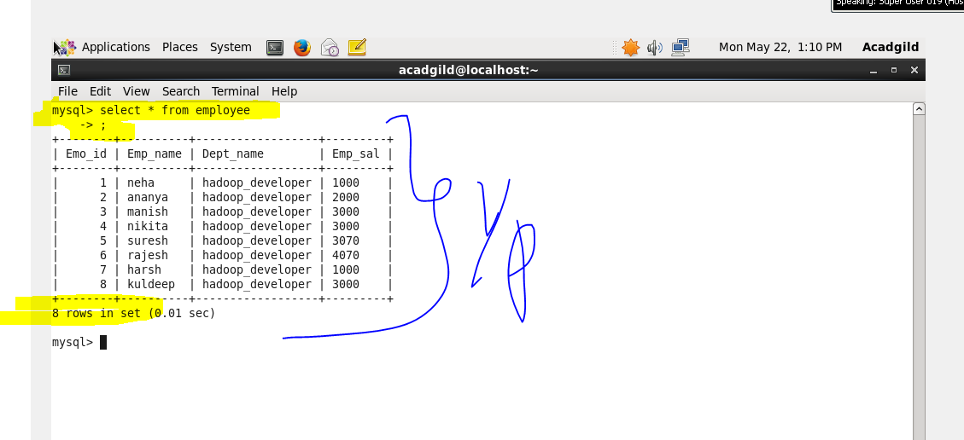

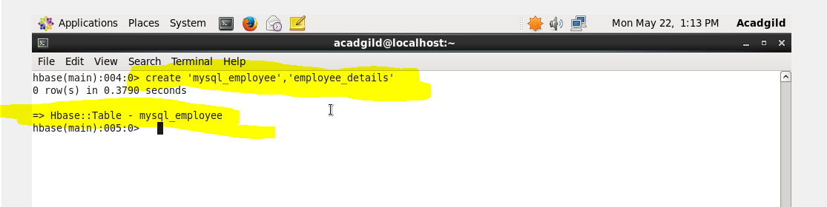

**SQOOP COMMAND TO DO IMPORT AND ITS EXPLANATION-**

**Sqoop import-import is used when we are importing data from rdbms to Hadoop ecosystem**

**--connect -> It is used to give the JDBC Url of database**

**--Username🡪user name of database**

**--P🡪password of database**

**--table 🡪 give the table you want to copy from MySql**

**--hbase-table🡪 the table in Hbase where It should be copied(here it is Mysql_employee)**

**--column family🡪given the column family as employedetails**

**--hbase-rowkey🡪which column should be taken as rowkey**

**-m1🡪number of mappers that should run**

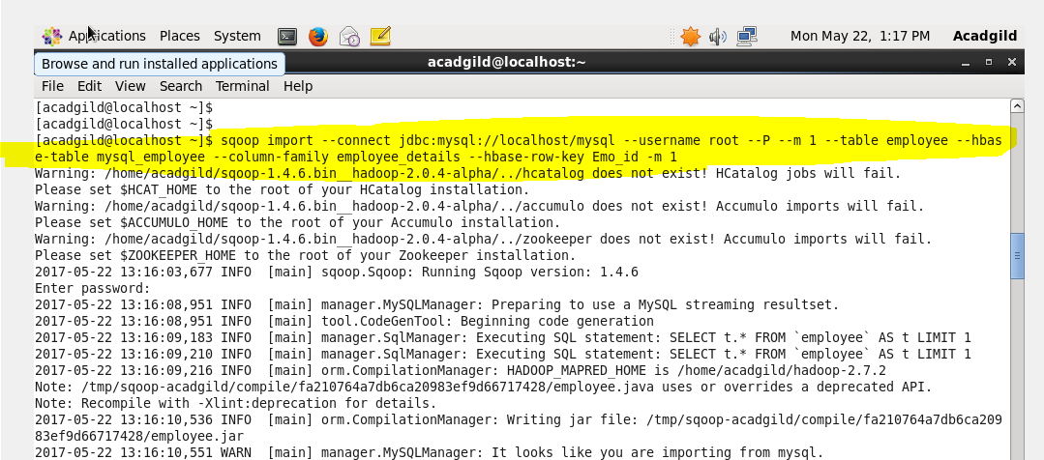

**From the above picture the table is successfully imported to Hbase-**

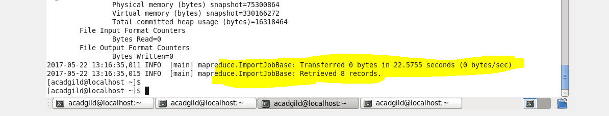

**OUTPUT-**

